QE for Digital Systems – 2015

1. Using Consensus Theorem: xy + yz + x’z = xy + x’z only (not the Karnaugh map), simplify (8)

F = a'b' + ac + bc' + b'c + ab

2. Simplify into a product-of-sum form using the following 5-variable Karnaugh map. All the blank entries indicate l’s. (12)

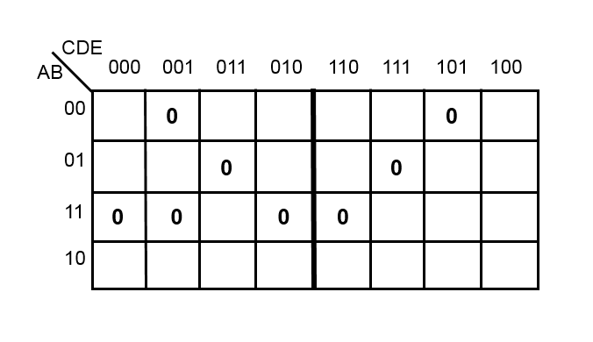
3. Problem on Adders (10)

What is the basic function of the half adder and the basic function of the full adder ? (2)
Compare their functions and their usages. (2)
Implement a half adder using two gates, show its inputs and outputs. (2)
Using two half adders and a gate, implement a full adder. (4)

4. Hardware → state table: Draw the state table for the following circuit. (10)

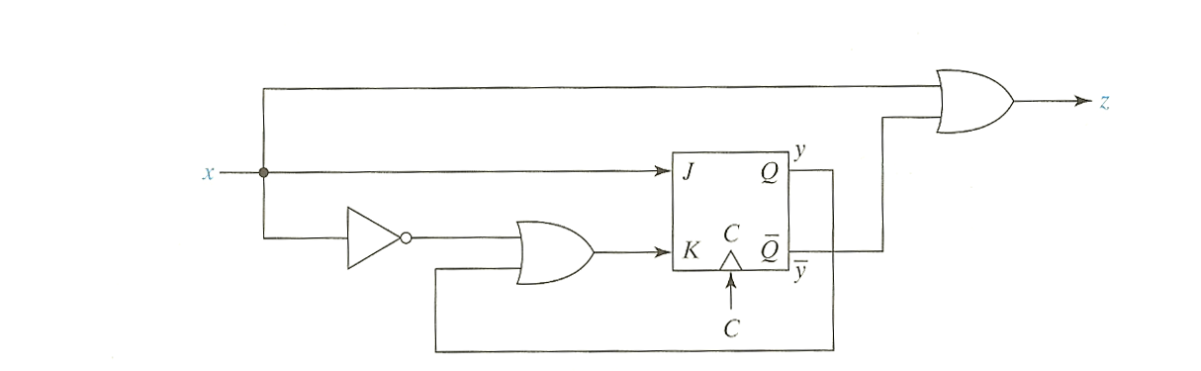

5. Design a counter that counts the number of people in a room as they are allowed to freely to leave or enter the room.
Show the kinds of needed inputs or outputs to and from the counter. Explain what each of them represents. Also show how the counter inputs are generated. You do not need to draw the state diagram for this machine. (10)

QE for Microprocessors – 2015

- (10 points) What are the three I/O (Input/Output) methods in microprocessors? Explain the principles and properties in terms with latency and throughput.
- (10 points) What are the major differences between microprocessor, CPU, DSP, ARM, FPGA, and GPU?
- (10 points) Explain the differences between CISC and RISC, in terms with instruction length, field format size, memory addressing mode, and operation complexity.
- (10 points) Explain three differences between real mode and protection mode in 32/64 bit microprocessors and explain them.
- (10 points) Draw a simple microprocessor system, consisting of control and data-path and explain the basic operations, using addressing modes with simple assembly codes.

